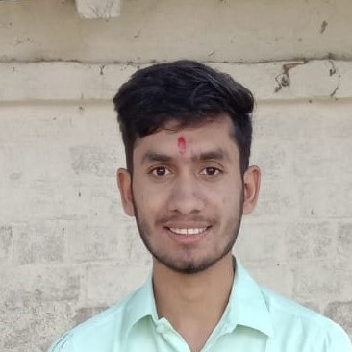**RESUME**

**AJEET KUMAR TIWARI**

GRAM PALIYA POST UMARI,REWA(M.P)

CONTACT: 8827940479

ALTERNATE CONTACT: 9098854796

LINKEDIN: <https://www.linkedin.com/feed/>

EMAIL ID: sanjutiwari1560@gmail.com

**To work with an organization where can learn new skill and increase my abilities for an organizational goals as well as myself .**

**EDUCATIONAL QUALIFICAFICATION**

* **B TECH COMPUTER SCIENCE & ENGINEERING (AIML):**

Technocrats institute of technology & science

11/2020 – 06/2024 cgpa-8.61(4th sem)

* **INTERMEDIATE:**

Saraswati Shishu Mandir ,Mangawan ,Rewa(M.P)

06/2019 – 06/2020 Percentage-65.2

* **X TH:**

Krishna H.S.School,Hanumanta ,Rewa(M.P)

05/2017-05/2018 marks- 84.6

**SKILL**

C (***)

C++ (***)

JAVA (***)

HTML (***)

CSS (***)

JS (***)

PYTHON (***)

SQL (***)

NON-TECHNICALSKILL

Teamwork

Time management

Problem solving

Self-Motivated

ACHIEVEMENTS

* **CODESHEF || Division [4]:**
* [**https://www.codechef.com/users/ajeet8827**](https://www.codechef.com/users/ajeet8827)
* Certification in core java .
* <https://www.hackerrank.com/certificates/b39890a7dd7b>
* Web development with python.

Language

English(***)

Hindi(****)

HOBBIES

Exercise

Spend time with my family

Writing

Playing Cricket

Photography